RECIPE OF SCONES

Ingredients :

-14 tablespoons floor

-3 tablespoons sugar

-1 teaspoon baking powder

-60g butter

-½ Glass of milk

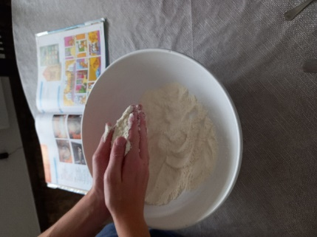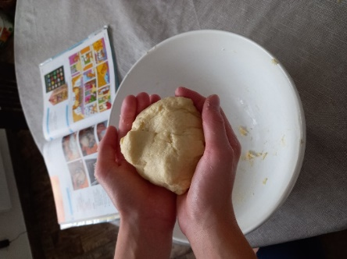

1.I mix together the flour, the salt,

the sugar and the baking powder.

Then I add the butter.

2. I add the milk to form the dough into

a ball

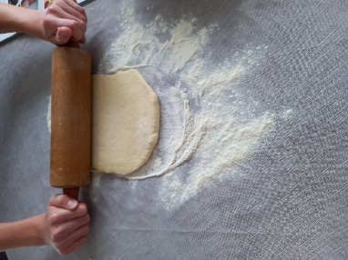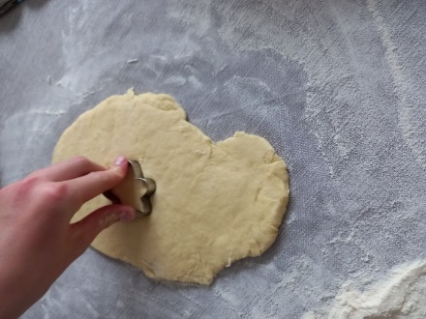

4. I cut the dough into stars.

3. I roll the dough out into

a 2.5 cm thick round.

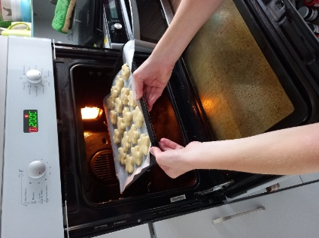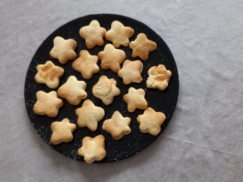

6. I enjoy my scones !

5. I bake in a hot oven for 15 minutes.